January 14, 2021
By Esayas Temesgen
…Sick and tired of being sick and tired: Eritrea deserves respect not mockery!
Gone is the time where the global air wave was dominated by very few media outlets, the major being the BBC that relished the upper hand in directing the world political chronicles because of its reach to the vast world audience.
Up until recently not only there was a shortage of competitive mass media but also the tools, such as a short wave radio transmitters or Television set and etc.…
At the time Television was out of reach to many nations, even where it was available it was not obtainable in every house hold. If it was would be in a bar or home of an individual who can afford to own one and generous enough to allow neighbors to watch local news.
Regardless, the international media giant- the B.B.C was accessed only on a short wave Radio. People gather around a person who was able to afford a Philips shortwave transistor to tune in once in twenty four hours to listen to B.B.C “World” news and comments.
Sometimes that was even out of range as a result one has to sift through a very week signal by raising the transmitter radio above his head as antenna to fine-tune the reception.
The BBC has taken this opportunity and used the circulation of short wave transmitter and the public thirst for information to its advantage to support its imperial tentacles that has a clout all over the globe.
Fortunately, these days with the advent of digital technology the domination of the world airwave by B.B.C and others world dominant Broadcasting Corporation through their financiers is winding down consequently if not obsolete but for sure it has diminished their relevance.
The advent of the digital technology accelerated the invention of social media that reversed the domination of these giant broadcasting corporates; as a result citizen journalist mushroomed around the globe disseminating vital information’s of public interest. Thus People through these social media are able to listen and watch to events as it happens in real time and respond, comment and fact check instantly at their fingertip, be it from a difficult place such as a battel field or areas of natural disaster.
Yet we are witnessing today, these media mogul such as the BBC ignoring this reality and engaged in disseminating fake news to perpetuate the narrative of their financiers, mainly the globalist; in undermining the information power of citizen of the world.
One example is the recent episode of the horrible conflict in Ethiopia between the maniac Junta from Tigray and the government, In the shadow of the upright transition of that nation to engage in a peaceful relation with its neighbor Eritrea after twenty years of Standoff.
Ethiopians are today for the third time in four decades trying to map out their future nation since the expulsion of Haillessellasse the absolute monarch from his throne who ruled with iron grip.
Although Ethiopians particularly the youth and the peasant welcomed the change because of the land reform – the revolution was awkwardly high-jacked by the military junta led by major Mengistu who eventually become the head of state by liquidating the “Durg” [the ruling military council.]
Major Mengistu for being ruthless fascist, butchering tens of thousands particularly the very youth who alleviated him to power become his eventual demise after seventeen years terrifying rule.
Fast forward, the rebel from Tigray region who took power over throwing the Military Junta lead by Major Mengistu turned-out to be more horrific than its predecessors.
Similarly this medieval mob because of its ethnic based federal government; genocidal tendency; broad corruption and ridicules - in your face looting of the country to its bone-Rejected bravely by the general public led by the more organized and the major nationalities; the Amhara’s and the Oromo’s.
The last straw that broke the back of this monster is… the apex of its crime against humanity: slaughtering of the Ethiopian army members of the Northern detachment, indiscriminately in their sleep; chopping the Breast and neck of young women soldiers with bayonet even inserting it in their privet part; shooting and imprisoning thousands, seizing some heavy and lite military hard-ware with intention to liquidate the fifty thousand strong army and march south to the capital Addis Ababa.
It didn’t stop there – organized a killing squad and slaughtered thousands civilians in a genocide fashion with machete and machinegun, exclusively of the Amhara nationalities in cities before they evacuate while running away from the approaching Ethiopian army. 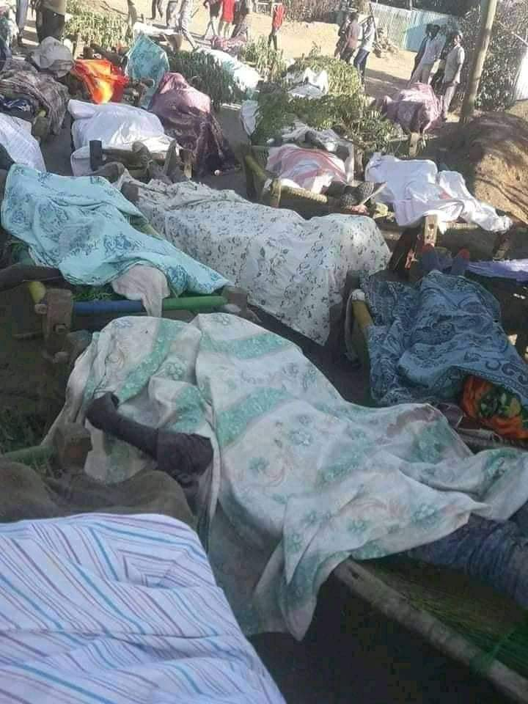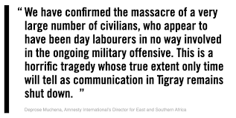by human right director for east and south Africa.
The regiment who survived the onslaught and cowardly act fought a life and death an uphill defensive battle with whatever is left in their hand, and crossed over to the neighboring Eritrea for temporary refuge until their reinforcement arrives.
This appalling spectacle falls in Eritrea’s hand, some were even with no cloth most haven’t consumed food for days. Remarkably Eritrea has to help these distressed Ethiopian soldiers graciously who were to begin with put at the border by these medieval mob to invade Eritrea.
Surprised Ethiopian soldier were in disbelief when they found themselves at the mercy of Eritreans and to be treated as friend rather than a foe: clothed, fed and let them keep their armament and send back to take on the cowardly Junta.
This phenomenon shade a light on the nonsense war of invasion on Eritrea that was launched by the Tigray mob at the end of 1900 through the early 2000.
The unexpected generosity from Eritreans made the Ethiopian solders to give it a thought on the past mistake, and comprehend the reality that they were duped by the medieval mob wrong information that the disputed little city at the border namely [Badme] was awarded to Ethiopia as a premises to wage an assault on Eritrea. That caused unnecessary loss of lives on both side. To be exact more than one hundred thousand Ethiopians and nineteen thousand Eritreans because of the blunt lie.
Consequently from the private to the rank and file of the solders came to realization established sympathy to Eritreans concern and to deal with, in an historic turn around the Ethiopian army aiming their gun to the real foe instead of Eritrea the “medieval mob’ started mopping them up from Eritrea border to the mountain of Temben, Ethiopia. To the place of their hideout back to where they originated; the rat hole.
Eritrea’s nobility was not limited there, the government by means of its good rapport with all three countries-is shepherding a shuttle diplomacy to find a peacefully resolution to the misunderstanding between Ethiopia and the Sudan in one hand and Ethiopia and Egypt on the other. Before it blows up into an all-out Arab/African war. Furthermore Eritrea positioned its troops at the border to discourage cross -border skirmish between Ethiopia and the Sudan.
However this being the reality on the ground Eritrea is mocked by mischievous individuals and groups, who have an ill intent on Eritrea in particular and Africa in general. In the topmost are Martin Plaut and his cohorts, racist fools; who are openly bulling Eritrea and intimidating the current government of Ethiopia lead by Prime Minister Abbiy Ahmed. To frustrate the historical peaceful relationship with Eritrea after twenty years of standoff. Which gained enthusiastic support from the public and for its appreciation of the long-due peace the international community awarded him a noble price.
These group enables and advocates by disseminating fake news and propaganda day in and day out in support of the medieval mob, masking its decades of crime against humanity and looting; with intent to destabilize Eritrea and Ethiopia so that they can control the region as they have been doing through their stooges like this brute medieval mob.
In the face of these volatility at its border and multiple provocative raid by this medieval mob from moving tanks and armories to cross the border, to launching salvo of rocket attack on Eritrea cities, terrorizing and frightening citizens to sleepless nights. What is Eritrea to do? Seat on its hand and cry uncle; Eritrea do not entertain that.
Considerably Eritrea should be complemented not scorned for following through its genuine intent to preserve the peace that obtained after decades of human and economic sacrifices. After all whenever necessary Eritrea has every right and responsibility to defend its people and territory without hesitation.
By Unleashing fake news, twisting the narrative about the incident; despite the glaring crime against humanity the world is witnessing: The selected mass killing of certain nationalities like in The Ogden, Oromia and now in Amhara region. Not to mention the mass grave and prison in every alley and airports of the country that was displayed to the world by the locals.
and undermining the over whelming support of the public for Prime Minister Abby Ahmed’s swift military action to wipe out the genocidal Junta to protect its citizens; The western media outlets astonishingly resented Ethiopians plea against this medieval mob’s heinous act:
The western media get their feed from individuals like Martin Plaut, a racist fool a former BBC World service Africa editor, who is making a living lobbing for notorious leaders like the Tigray junta of Ethiopia and others like them on the international political arena to facilitate the plundering of Africa through these rootless leaders.
Martin Plaut uses his connection with The BBC and other media outlets to disseminate propaganda for his clients. He has a beef with countries like Eritrea because of their firm stance against intrusion and exploitation of Africa by the neo colonizers/the globalist…He has been nosing-in between the two neighboring countries to make sure that there will be no reconciliation so that he will stay in business.
He turned on Ethiopia because Prime Minister Ahmed’s from the Oromo national pragmatist outlook for the future of his country negates past self-distracting western financed expansionist policy of his predecessors. A policy that has immersed the nation with none ending conflict with its neighbors; unrest and resentment at home; causing a cyclical starvation and perpetual poverty; in spite of the country’s rich natural resource, fertile land and abundance of water.
This gutless posturing by these western media to support this medieval mob is insulting to Africans; they think they know better for Africa than Africans. It exposes the hidden agenda of the white people. Their interest in Africa is not the people welfare and safety as they claim, it is rather exploitation of the natural resource that was feeding their greed for century on a cheap through colonial power, when that failed…Then transformed to a new face as “globalist.”
During the scramble for Eritrea in the late 1940’s before the war was over the Italians and the British were at the last leg of it in Keren. The British army after beating the Italians at kern on their way to Asmara the captain run into an Eritrean women ululating to show joy of her country’s liberation from Italians not knowing that the British evil intent, until the British Captain to her dismay said to her “I didn’t do it for you nigger.”
That Eritrean mother takes him at his word and Eritreans believed him, that is why Eritreans commence a mass organization to eject the occupier in the early nineteen fifties and the armed struggle in nineteen sixty one and the rest is history.
This exemplify how the white man think of Africa; if you think Martin Plaut [the racist fool] think otherwise think again. He view Ethiopia the way a private equity firm seize up an aging conglomerate.
The difference between the British Captain and The Martin’s is…the British Captain is forthright to convey his marching order. The Martin’s mask themselves under fancy words like…NGO; EXPERTS ON AFRICA; CIVICSOCITY; HUMAN RIGHT;GREEN PEACE; This GROUP That GROUP. They throw bunch of baloney.
These individuals and groups must be blood liable for their meddling in Africa’s affairs.
Never mind Eritrea wins its independence after an elongated war; never mind hold referendum to full fill its international obligation; never mind repelled invasion time and time again; never mind wins its border dispute with its neighbor Ethiopia fair and square at the international court; never mind Eritrea goes out of its way three times to help its neighbor Ethiopia to resolve internal strife. And Yet Eritrea is maligned by these racist fools-is annoying to say the least. However, whatever these racist fools and their local stooges do, can’t frustrate Progressive Eritrea.
Black life matter!
Awate N’ hafash!

